Fast Water Exchanges on Aqueous Ions and a Mineral Surface Resolved Using Molecular Dynamics Validated by Quasi-Elastic Neutron Scattering.

Andrew G. Stack*1, José M. Borreguero2, Eugene Mamontov3, Hsiu-Wen Wang4, Lukas Vlcek5, & David J. Wesolowski1

1 Chemical Sciences Division, Oak Ridge National Laboratory

2 Neutron Data Analysis & Visualization Division, Oak Ridge National Laboratory

3 Chemical & Engineering Materials Division, Oak Ridge National Laboratory

4 Joint Institute for Neutron Sciences, University of Tennessee

5 Joint Institute for Computational Sciences, University of Tennessee

* Corresponding author e-mail address: stackag@ornl.gov

**ABSTRACT:**  Solvent exchange on solid surfaces and aqueous ions is a fundamental property of reactions in liquids, but the magnitudes of the rates are poorly constrained for fast exchanges. We have probed the fast dynamics of water adsorbed onto nanoparticles of the mineral barite (BaSO4) using quasi-elastic neutron scattering (QENS) and classical molecular dynamics (MD). QENS data as a function of temperature and momentum transfer (*Q*) were fit using scattering functions derived from MD trajectories. The MD fit reproduces the dynamics measured in the QENS experiments well at ambient temperatures, but MD fit quality degrades at high *Q* as temperature is lowered. Once validated on the dynamics of the system, the MD model is used to calculate the mean residence times of water at room temperature on surface sites on the {001} barite surface. These include 194 ps and 84 ps on the two barium surface sites and 13 ps on both sulfate sites (300 K), but multiple exchange distributions are sometimes observed. Water residence times on the aqueous ions are similar to some of the surface sites:  is 208 ps and  is 5.8 ps. This work demonstrates that combined QENS and MD is a useful tool to tightly constrain solvent exchange rates.

**KEYWORDS:** barite, water exchange, quasi-elastic neutron scattering, molecular dynamics, aqueous barium ion, aqueous sulfate ion

**Introduction**

Published rates of water exchange reactions on aqueous ions span some twenty orders of magnitude.1 The fastest published experimental estimates of the rates of exchange are ~1010 s-1, or 100 ps residence time,1,2 whereas both rotational and translational diffusional events in bulk water have a ~1 ps residence time near room temperature.3 As a fundamental property, exchange rates of the aqueous ions have been shown to correlate with the rates of more complex reactions such as the rates of dissolution of crystalline materials composed of those same ions,4,5 although absolute magnitudes of the elementary rate limiting steps are likely slower.6 For growth of crystalline materials, process-based models have resulted in rate constants for ion attachment that are ~0.5-4 orders of magnitude slower than accepted rates of water exchange on the aqueous ions.6-9

The most rapid water exchanges on aqueous ions are too fast to observe using Nuclear Magnetic Resonance Spectroscopy, often the technique of choice for their measurement.1 Fast exchange times for water molecules in the first hydration shell are therefore not well-constrained for many aqueous ions. Examples include calcium, strontium, barium, and oxyanions such as aqueous sulfate, carbonate or nitrate. Accepted values are not always direct measurements of water exchange but are sometimes estimates based on measurements of the diffusional properties of an ion10,11 or its chelation behavior.12 For solids, measurements of the rates of water exchange are often ambiguous since, in addition to the issues for aqueous ions, multiple surface structures, sites and distributions of particle morphology complicate interpretation of the results.13 Recent efforts to model water exchange reactions using atomistic computational methods14-20 have proven sufficiently successful that a limiting factor in evaluating the validity of the dynamics in a computational model is now the uncertainty in the experimental estimate.21 This uncertainty undermines our ability to use these models predictively to understand the kinetics and mechanisms of other, unknown reactions.6,22-25

We report here on classical molecular dynamics (MD) simulations of water exchange on the four different surface sites comprising the {001} surface of barite (BaSO4). The validity of the dynamics in the MD simulations was established by fitting the water motions to quasi-elastic neutron scattering (QENS) measurements of the diffusional motions of water adsorbed to barite (BaSO4) nanoparticles. We chose barite because of its importance in medical imaging, heavy drilling muds, and its potential application to control the mobility of toxic metals (barium and radium)26 released during hydraulic fracturing27 or spent nuclear fuel disposal.28 Furthermore, its water exchange rates and those of its constituent ions are currently not well constrained. Previous estimates for the mean residence time of a water molecule in the first solvation shell of the aqueous barium ion span two orders of magnitude (100-2,000 ps): a measurement from competitive ligand exchange12 is 200-2000 ps and the often-quoted literature-value is actually a QENS estimate based on the diffusion of Ca2+(*aq*), from which residence times for Ba2+(*aq*) of 100-1000 ps are inferred.10,2 Values calculated from atomistic computational simulations have ranged from 14.6-208 ps.16,22,25,29,30 The water exchange rate of aqueous sulfate ion or sulfate on mineral surfaces have not been reported to our knowledge.

**Experimental and Computational Methods**

Barite nanoparticles31 (Sachtoperse, HU-D) with a surface area of 40 m2/g were used for the QENS experiments. Their hydration level in laboratory air (~22 °C, 60% rel. humidity) was determined by thermogravimetric analysis-mass spectrometry (TGA-MS) (Supporting Information, Figure S1). 2.2% water weight was found on the nanoparticles with no significant hydrocarbons or other surface contaminant observed. Significant molecular water releases were observed at 90 and 283 °C. Transmission Electron Microscopy was performed to verify the crystalline character and morphology of the samples. Nanoparticles were ~20-50 nm in diameter and observed morphologies were often consistent with a common habit for barite consisting of right rhombic prisms dominated by the {001} and {210} surfaces32,33 (Figure 1).

The QENS measurements were made on the Back-Scattering Silicon Spectrometer (BASIS) at the Spallation Neutron Source at Oak Ridge National Laboratory. Details of the instrument are described elsewhere.34,35 The dynamic range chosen for this experiment was -100 to 500 μeV with a 0.4 μeV bin width and ~3.4 μeV resolution at Full Width Half Maximum (FWHM). Temperatures were ramped from 300 to 230 K, with an additional measurement at 14 K to obtain the resolution function. Momentum transfer (*Q*) values suitable for analysis were limited by the location of the first Bragg peak for barite, thus only *Q* values of 0.3, 0.5, 0.7, 0.9 and 1.1 Å-1 were used. Uncertainties listed below for both experimental and computational work are associated with the confidence of the fit parameter value (1 standard deviation).

MD was performed using the previously described37 “alternate” implementation of the MSXX force field, a non-polarizable, simple point charge model that incorporates a flexible water model (F3C).38 For simulations on barite, a simulation supercell of 34.4475 × 28.1442 × 57.2552 Å3 were created for the {001} barite surface, with the same ratio of water content by mass as observed in the TGA-MS (320 formula units of BaSO4 and 365 water molecules; approximately 4.5 water molecules per surface formula unit of BaSO4). A snapshot of this cell is shown in Figure 2. Four different surface sites are present on the {001} surface, two barium and two sulfate sites, each in “high” and “low” positions.To calculate the water exchange on the aqueous sulfate ion, a simulation cell 20 × 20 × 20 Å3 was used containing 801 water molecules and 1 sulfate ion. (Water exchange on aqueous barium ion using this force field was previously reported.)16 Simulations were performed using LAMMPS39 in the NVT ensemble at the same temperatures as the QENS measurements, equilibrated for 1 ns, run for 10 ns with a 1 fs timestep, and atomic positions reported every 0.1 ps. Incoherent intermediate scattering functions were derived from the atomic trajectories of the water molecules using the SASSENA software package40 and model scattering functions were obtained with the MANTID software package.41

**Results and Discussion**

Data for the QENS measurements and their fits are shown in Figure 3. QENS data were fit using the common expression reflecting the sum of the elastic, inelastic and background contributions:42,43

 (1)

where *I*(*E*) is the intensity of the scattering signal at a given energy transfer (*E*), *A* is the peak area, *x* is the fraction of elastic scattering, δ(E) is the delta function for the elastic peak centered at zero energy transfer, *B*(*E*) is a linear background containing an intercept and slope, and *R*(*E*) is the resolution function (measured at 14 K; Figure 3). *S*(*E*) is the model scattering function derived from the MD simulation trajectories. This is calculated using the two-point self correlation function of just the water in the simulation trajectories, weighted by the incoherent neutron scattering length:

$I\left(Q,t\right)={〈\frac{1}{N}\sum_{i=1}^{N}{{\left(b_{i}^{(inc)}\right)}^{2}}e^{-i\vec{Q}\left(\vec{r_{i}}\left(t_{0}\right)-\vec{r_{i}}\left(t_{0}+t\right)\right)}〉}_{{t_{0},Ω}_{\vec{Q}}}$ (2)

where *I*(*Q,t*) is the intermediate structure factor as a function of momentum transfer, *Q*, and time, *t*, *i* is the *i*th atom of total *N*, $b_{i}^{(inc)}$ is the incoherent scattering length for atom *i*, $\vec{r_{i}}$ is the atom’s position vector at the starting configuration, *t0*, or at time *t+t0*, and represents an average over all starting configurations and all orientations of the scattering vector, $\vec{Q}$. To generate the model scattering function (i.e., the dynamic structure factor), theFourier transform of the intermediate scattering function was taken and the Schofield correction applied to account for detailed balance:44

(3)

where *E* is the energy transfer and other symbols have their usual meanings. No additional fit parameters were used to derive this *S(E)*. Both elastic and inelastic components arising from the incoherent dynamics of the water in the simulations are included.

The QENS data, MD-derived scattering function fits are shown in Figure 3a, b (Figure 3c and d are the same data, but showing only the ±0.025 meV energy transfer range). For brevity, only data for *Q* = 0.3 and 1.1 Å-1are shown, but data and fits for intermediate *Q* values are shown in the Supporting Information (Fiugure S2). χ2 Goodness-of-Fit test statistics over all Q values are shown in Figure 4. Overall the fits using the MD trajectories give a close match to QENS data, suggesting the dynamics of the MD model accurately reproduce the observed diffusional dynamics. Fit quality between ±0.01 meV does decreases at high *Q* as temperature decreases however. This is evident in the residuals shown in Figures 3e and f: while the residuals to the fit for the *Q* = 0.3 Å-1 data are roughly constant across temperatures (Figure 3e), there is an increase in the residuals at low temperature at *Q* = 1.1 Å-1. The *χ*2 statistics as a function of *Q* and temperature shown in Figure 4 demonstrate that the decrease in fit quality is progressively degrades at high *Q* as temperature is lowered. That only the fits at high *Q* degrade at low temperature suggests the MD model is failing to capture some dynamics of localized translational motions (e.g., a jump diffusion model becomes independent of *Q* at high *Q* and corresponds to the reciprocal of the residence time for translational motions).3

A likely source for this deviation is because the MD force-field parameters for ion-water interaction were calibrated using simulations at room temperature37 so the decrease in fit quality with decreasing temperature could be explained by an increasingly inaccurate MD model diffusional dynamics at progressively lower temperatures. Particularly relevant is that only the hydration free enthalpy of the aqueous ions, and lattice enthalpy of the solid, were estimated, and the temperature-dependent portions of the hydration free energies were not tested. A second source of uncertainty is that the simulations here were performed solely on the {001} surface of barite whereas barite particles have more than one surface present with possibly different interfacial dynamics. While it is difficult to estimate the relative proportions of different surfaces exposed on the nanoparticles used here, the assumption that the dynamics of the {001} surface are representative of the barite nanoparticles is reasonable. That is, the {001} is the lowest energy surface for barite,32 and often only the {001} and {210} are observed33 (Figure 1). Furthermore, the coordination environment of half the surface sites exposed on the {210} are identical to sites in the {001}, which suggests their dynamics may also be similar.37 Thus any improvement in fit quality that might be obtained by a multi-surface dynamical model would not likely be sufficient to justify the increased complexity and larger number of fit parameters required to adjust the relative proportions of dynamics from different surfaces.

Once the overall dynamics of water in the MD model has been validated by fitting to the QENS data, it can be used to reliably calculate the residence times of water molecules on individual surface sites on the barite {001} (Figure 5). These were calculated using a direct counting method17 since water exchanges in this system are fast relative to total simulation time and the large number of sites in the simulation supercell provided adequate statistics for exchange events. In this method, first, a definition for if a water molecule is associated with a surface site is made by establishing the furthest limit of water that can be considered as still bound to that site. This was done here by calculating the average radial distribution function between each type of site and the oxygens on water molecules,17 and the minima between the first and second shell water determined (shown in the Supporting Information, Figure S3). These were located at 360 pm from barium surface sites and 400 pm from oxygens on sulfate surface sites. For the sulfate sites, it was found that this definition was overly broad and included some water molecules that were actually associated with barium sites, so any oxygen on water that was within 400 pm for sulfate but also within 360 pm of a barium site was considered as associated with the barium. Approximate sizes of the first shell water are shown in Figure 2a as the green and yellow circles surrounding barium and sulfate sites, respectively. Next, the length of contiguous time each water molecule in the simulation was associated with each surface site was calculated. Since waters may leave a site temporarily in an unsuccessful exchange attempt, a cutoff time must be used to correctly count only successful exchanges. Transmission coefficients in the reactive flux method often reach a plateau in a 1-2 ps timescale,15-17 so a water that leaves a site for less than 1-2 ps, or stays on a site for less than 1-2 ps, is more properly considered as an unsuccessful water exchange attempt rather than a short exchange. After calculating the time a water molecule spends associated with a site, distributions of the base-10 logarithm of the observed residence times were plotted as a histogram. We initially observed that a 1 ps cut-off for exchanges led to a large number of exchanges on sulfate surface sites precisely 1 ps long without an accompanying distribution of exchange events, especially at lower temperatures (Supporting Information, Figure S4). This indicates that they are not actual exchanges but are instead unsuccessful attempts, therefore a more conservative 2 ps cutoff16 was used to generate the final residence times (Figure 6). For sites where a single distribution of exchanges was observed in the histogram, the mean of the logarithm of the observed residence times was calculated. However, the histograms revealed two distributions of exchanges for some sites (Figure 6). In these cases, the histograms were fit using multiple normal distributions with Igor Pro’s (Wavemetrics, Lake Oswego, OR, USA) multi-peak fitting software package.

**Table 2:** Mean Residence Times at 300 K and Activation Energies for Water Adsorbed to Barite Surfaces and Aqueous Ions (uncertainties are one standard deviation in confidence interval for the fit).

|  |  |  |
| --- | --- | --- |
|  | Residence Time at 300 K (ps) | Activation Energy (kJ/mol) |
| Water Exchange on Surface Sites | | |
| low barium | 194 | 23.4 ± 0.8 |
| high barium | 84 | 17.1 ± 0.3 |
|  | 2.5 | 3.5 ± 1.3 |
| low sulfate | 12 | 7.3 ± 1.1 |
| high sulfate | 14 | 10.1 ± 0.2 |
|  | 65 | 20.7 ± 1.0 |
| Water Exchange on Aqueous Ions | | |
|  | 208 |  |
|  | 5.8 |  |

The mean residence time for the six distributions of water detected on the four barite {001} sites are plotted in Figure 5 and the values at 300 K are listed in Table 2. The slowest residence times observed were on the low barium surface sites, 194 ps at 300 K, and is close to the rate of water exchange on the aqueous barium ion previously calculated using this force field, 208 ps.16 This is also within the order of magnitude range of one of the previous estimates for aqueous barium ion inferred from the diffusional motions measured on aqueous calcium ion.10 Many recent computational estimates have resulted in residence times significantly shorter than this, in fact, 208 ps is the longest residence time of any of the computational estimates of water exchange on aqueous barium ions.15,22,25,29,30

On the second, high, barium site, two distributions of water residence times were observed, with mean residence times of 84 and 2.5 ps. This is reasonable since the average number of coordinated water molecules for this site is 2.01 ± 0.02 whereas the low barium site contains an average of 0.96 ± 0.01 and correspondingly contains only a single distribution of residence times. This is also evident from Figures 2b,c where two distinct regions of high probability water are detected coordinated to the high barium sites whereas only one is observable for the low barium site. This does not explain the relative magnitudes of the residence times on the high and low sites, however, which presumably are due to the relative under- and over-saturation of the coordination environments of the two sites and the steric availability of sorbed water to become displaced.37 With a magnitude of 2.5 ps at 300 K, the second exchange on the high barium site is close to the residence time for translational and rotational motions in bulk water (~1 ps),3 suggesting that this water species is not strongly bound to the high barium site.

Although arising from water molecules associated with different surface sites, the similar rates of water exchange on the low barium (τ = 84 in Table 2) and one of the high sulfate (τ = 65 ps) exchanges are likely representing the same process, which is intra-surface water exchange between neighboring barium and sulfate sites. This observation is supported since some overlap in the coordination of sulfate and barium sites was observed, as noted above, and a contiguous connection of the lower probability isosurfaces between the high barium and high sulfate sites is discernable in Figure 2c. Lastly, intra-surface water exchange has been observed previously in the interlayers of a clay, although the activation energies for exchange are higher here (17.1-20.7 versus ~6 kJ/mol in the clay).49

Of the two remaining distributions of water residence times on sulfate, their similarity (τ = 14 and 12 ps) is likely due to similar water coordination environments and binding energy. Specifically, the average coordination number for the surface oxygens on the two sulfate sites are 1.35 ± 0.43 and 1.06 ± 0.01 for the high and low sites, respectively. If the lateral exchange on the low sulfate site (τ = 65 ps at 300 K) is discounted as controlled by the neighboring high barium site, the mean residence time for water on both sulfate sites is 13 ps. Using the same methods, we obtained an average first-shell water residence time for an aqueous sulfate ion of 5.8 ps, only slightly faster than the water sorbed onto the sulfate surface sites. This is the first time the rate of water exchange has been measured on an aqueous sulfate ion to our knowledge.

The work here supports a hypothesis that in a rough sense the residence times of water predicted by this model on both barium and sulfate surface sites lie in a continuum somewhere in between the residence time of water on the aqueous ions and that of self-diffusion of bulk water. Precisely how the residence time is on a surface site differs relative to these two end-members presumably depends primarily on the coordination environment of the surface site to its surrounding ions in the mineral and to water. Steric factors will also play a role, as it has been previously observed that barium surface sites on the barite {001} are under-coordinated relative to what one would predict based on their local bonding environments.37 For other materials and computational models, evidence on the relative magnitude of water exchanges rates on surfaces and aqueous ions is inconsistent; some models predict shorter residence times on the aqueous ions than on surface sites,14 whereas different materials and other force fields predict longer residences times.18,19 Ultimately it is too soon to make a broad generalization about water exchange rates on surfaces versus aqueous ions, particularly since in this work we show that there can be variation of residence times for even a single site, much less the variation amongst different sites.

**Conclusions**

The direct fitting of scattering data from model scattering functions calculated from MD trajectories provides a quantitative measure of the validity of the water dynamics of the MD model. Once the dynamics are validated, plausible water exchange rates of surface sites on a barite {001} surface can be calculated. Mean residence times of water observed on barium surface sites were 194, 84 and 2.5 ps, whereas sulfate surface sites averaged 13 ps at 300 K and one lateral exchange between adjacent barium and sulfate sites was observed with residence time of 65 ps. We further conclude that the calculated water exchange rate of the aqueous barium ion, 208 ps, made using a variation on this MD model16 should be considered as the best available estimate. Lastly the residence time of water on aqueous sulfate ion, 5.8 ps, was found to be similar to the sulfate surface sites (~13 ps).

**Acknowledgment.** This research was sponsored by the Division of Chemical Sciences, Geosciences, and Biosciences, Office of Basic Energy Sciences, U.S. Department of Energy. QENS measurements were made at Oak Ridge National Laboratory's Spallation Neutron Source, sponsored by the U.S. Department of Energy, Office of Basic Energy Sciences. Fitting of structure factors from simulations was developed as part of CAMM, funded by the U.S. DOE, Basic Energy Sciences, Materials Sciences and Engineering Division.

**Supporting Information**. TGA-MS data, QENS data and fits across all *Q* ranges measured, pair distribution functions for barite surface sites and water exchange distributions using a 1 ps cut-off. This material is available free of charge via the Internet at http://pubs.acs.org.

**References**

(1) D. T. Richens, *The Chemistry of Aqua Ions.* Wiley, 1997.

(2) L. Helm, Merbach A. E., *Coord. Chem. Rev.* 1999, **187**, 151-181.

(3) J. Teixera, M.-C. Bellissent-Funel, S. H. Chen, A. J. Dianoux *Phys. Rev. A,* 1985, **31**, 1913-191714.

(4) O. S. Pokrovsky, J. Schott,*Environ. Sci. Technol.,* 2002, **36**, 426-432.

(5) W. H. Casey, C. Ludwig *Rev. Mineral. Geochem.,* 1995, **31**, 87-118.

(6) A. G. Stack, P. Raitieri, J. D. Gale, *J. Am Chem. Soc.,* 2012, **134**, 11-14.

(7) A. G. Stack, M. C. Grantham, *Cryst. Growth Des.*, 2010, **10**, 1409-1413.

(8) A. G. Stack, *Greenhouse Gases Sci. Technol.,* 2014, **4**, 278-288.

(9) J. N. Bracco, A. G. Stack, S. R. Higgins, *Environ. Sci. Technol.,* 2014, **14**, 6033-6040.

(10) P. S. Salmon, *J. Phys. C: Solid State Phys.* 1987, **20**, 1573-1587.

(11) P.S. Salmon, W. S. Howell, R. Mills, *J. Phys. C: Solid State Phys.* 1987, **20**, 5727-5747.

(12) M. Eigen, *Pure Appl. Chem.* 1963, **6**, 97-115.

(13) J. Rosenqvist, W. H. Casey, *Geochim. Cosmochim. Acta*, 2004, **68**, 3547-3555.

(14) S. Kerisit, S. C. Parker, *J. Am. Chem. Soc.* 2004, **126**, 10152-10161.

(15) J. R. Rustad, A. G. Stack, *J. Am. Chem. Soc.* 2006, **128**, 14778-14779.

(16) A. G. Stack, J. R. Rustad, *J. Phys. Chem*. 2007, **111**, 16387-16391.

(17) D. Spångberg, R. Rey, J. T. Hynes, K. Hermansson, *J. Phys. Chem. B* 2003, **107**, 4470-4477.

(18) J. Wang, J. R. Rustad, W. H. Casey, *Inorg. Chem.* 2007, **46**, 2962-2964.

(19) S. Kerisit, K. M. Rosso, *J. Chem. Phys.* 2009, **131**, 114512.

(20) P. Raiteri, J. D. Gale, D. Quigley, P. M. Rodger, *J. Phys. Chem. C* 2010, **114**, 5997-6010.

(21) A. G. Stack, J. D. Gale, P. Raiteri *Elements* 2013**,** **9**, 211-216*.*

(22) A. E. Hofmann, I. C. Bourg, D. J. DePaolo *Proc. Natl. Acad. Sci. USA* 2012, **109**, 18689-18694.

(23) L.-M. Liu, A. Laio, A. Michaelidis, *Phys. Chem. Chem. Phys.* 2011, **13*,*** 13162-13166.

(24) J. R. Rustad, J. S. Loring, W. H. Casey, *Geochim. Cosmochim. Acta* 2004, **14**, 3011-3017.

(25) J. P. Larentzos, L. J. Criscenti, *J. Phys. Chem. B* 2008, **112**, 14243-14250.

(26) A. J. Martin, J. Crusius, J. J. McNee, E. K. Yanful, *Appl. Geochem.* 2003, 18, 1095-1110.

(27) K. J. Ferrar, D. R. Michanowicz, C. L. Christen, N. Mulcahy, S. L. Malone, R. K. Sharma, *Environ. Sci. Technol.* 2013, **47***,* 3472-3481.

(28) E. Curti, K. Fujiwara, K. Iijima, J. Tits, C. Cuesta, A. Kitamura, M. A. Glaus, W. Müller, *Geochim. Cosmochim. Acta*, 2010, **74**, 3553-3570.

(29) S. Piana, F. Jones, J. D. Gale, *J. Am. Chem. Soc.* 2006, **128**, 13568-13574.

(30) T. S. Hofer, B. M. Rode, B. R. Randolf, *Chem. Phys.*, 2005, **312**, 81-88.

(31) W. Vogelsberger,J. Schmidt, *J. Phys. Chem. C* 2011, **115**, 1388-1397.

(32) N. L. Allan, A. L. Rohl, D. H. Gay, C. R. A. Catlow, R. J. Davey, W. C. Mackrodt, W. C., *Faraday Discuss.*, 1993, **95**, 273-280.

(33) P. Hartman, C. S. Strom, *J. Cryst. Growth*, 1989, **97**, 502-512.

(34) E. Mamontov, D. J. Wesolowski, L. Vlcek, P. T. Cummings, J. Rosenqvist, W. Wang, D. R. Cole, *J. Phys. Chem. C* 2008, **112**, 12334-12341.

(35) E. Mamontov, K. W. Herwig, *Rev. Sci, Inst.* 2011, **82**, 085109.

(36) R. T. Azuah, L. R. Kneller,Y. Qiu, P. L. W. Tregenna-Piggott, C. M. Brown, J. R. D. Copley, R. M. Dimeo,  *J. Res. Natl. Inst. Stan. Technol.* 2009, **114**, 341-358.

(37) A. G. Stack, *J. Phys. Chem. C* 2009, **113**, 2104-2110.

(38) M. Levitt, M. Hirshberg, R. Sharon, K. E. Laidig, V. Daggett, *J. Phys. Chem. B.* 1997, **101**, 5051-5061.

(39) S. J. Plimpton, *J. Comp. Phys*. 1995, **117**, 1-19.

(40) B. Lindner, J. C. Smith, *Comp. Phys. Comm.* 2012, **183**, 1491-1501.

(41) J. Taylor, O. Arnold, J. Bilheaux, A. Buts, S. Campbell, M. Doucet, M. et al. *Bull. Am. Phys. Soc.*,2012, **57***,* W26.00010.

(42) E. Mamontov, L. Vlcek, L.; D. J. Wesolowski, P. T. Cummings, J. Rosenqvist, W. Wang, D. R. Cole, L. M. Anovitz, G. Gasparovic, G., *Phys. Rev. E* **2009**, 79, 051504.

(43) E. Mamontov, L. Vlcek, D. J. Wesolowski, P. T. Cummings, W. Wang, L. M. Anovitz, J. Rosenqvist, C. M. Brown, V. G. Sakai, *J. Phys. Chem. C,* 2007, **111**, 4328-4341.

(44) P. Schofield, *Phys. Rev. Letters* 1960, **4(5)**, 239-240.

(45) E. Mamontov, *J. Phys. Chem. B,* 2013, **117**, 9501-9507.

(46) M. Bée, *Quasielastic Neutron Scattering: Principles and Applications in Solid State Chemistry, Biology and Materials Science*. Adam Hilger, Bristol, 1988**.**

(47) G. Stirnemamann, D. Laage, D. *J. Chem. Phys.* 2012, 031101.

(48) D. Chandler, J. P. Garrahan, *Annu. Rev. Phys. Chem.*, 2010, **61**, 191-217.

(49) C. P. Morrow, A. Ö. Yazaydin, M. Krishnan, G. M. Bowers, A. G. Kalinichev, *J. Phys. Chem. C*, 2013, **117**, 5172-5187.

(50) D. J. Wesolowski, J. O. Sofo, A. V. Bandura, Z. Zhang, E. Mamontov, *Phys. Rev. B*, 2012, **85**, 167401.

(51) H.-W. Wang, M. J. DelloStritto, N. Kumar, A. I. Kolesnikov, P. R. C. Kent, J. D. Kubicki, D. J. Wesolowski, J. O. Sofo, *J. Phys. Chem. C* 2014, **118**, 10805-10813.

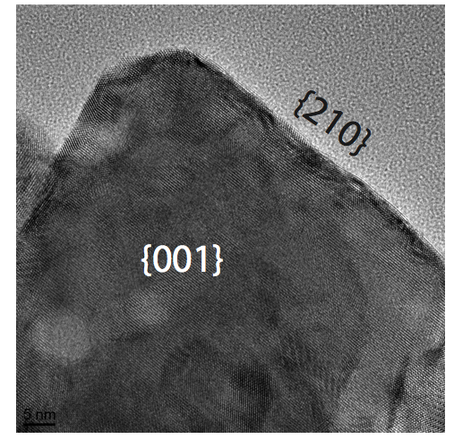

**Figure 1** TEM image of barite nanoparticle, scale bar is 5 nm. Crystalline particles ranging from 20-50 nm in diameter were observed.The morphology is consistent with the {001} and {210} surfaces as being dominant.

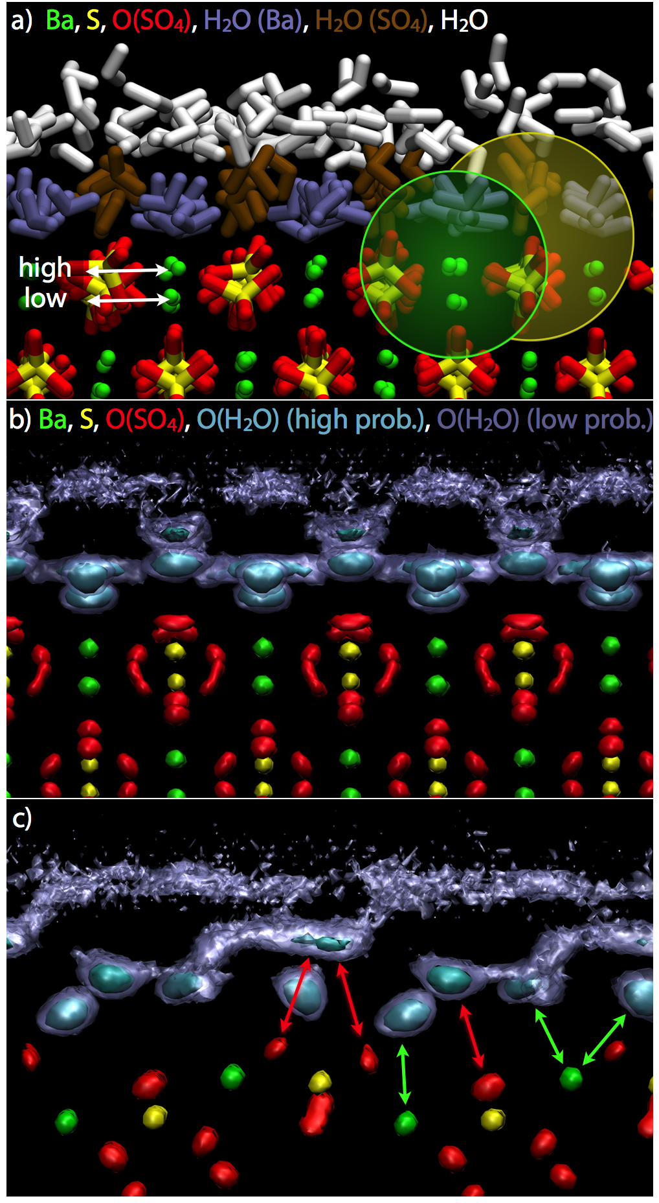

**Figure 2.** Results from the MD simulation of the {001} barite surface with adsorbed water, viewed along [100]. **a)** Simulation snapshot. There are two barium and two sulfate sites exposed at the interface: high and low. Water molecules can coordinate either of these sites or none at all. Bariums are green, sulfurs are yellow, oxygens on sulfate are red. Water coordinated to barium surface sites are purple, water coordinate to sulfates are brown and the remaining water are white. The green and yellow circles show the extents of the first shell water for barium and oxygens on sulfate sites, respectively. **b)** Probability isosurfaces of a 300 K simulation. The association of oxygens on water with surface sites form areas of high probability areas that are cyan in color whereas the extended network of interfacial water form the low probability areas that are purple. **c)** Probability isosurfaces, viewed along [011]. The locations of the water coordinated with barium and the oxygens on sulfate sites are labeled with green and red arrows, respectively.



**Figure 3**. QENS data (points) and fits (lines) as a function of temperature, energy transfer and momentum transfer (*Q*). The black line is the resolution function. Data is fit to equations 1 & 2 using MD trajectories for **a)** *Q* = 0.5 Å-1 and **b)** *Q* = 1.1 Å-1. (Intermediate *Q* values are shown in the supporting information, Figure S2.) Energy transfer values close to the elastic peak for both *Q* values are shown in **c)** and **d)**, along the residuals from MD fit in **e)** and **f)**. In e) and f), the data have been staggered for clarity.



**Figure 4.** *χ*2 goodness-of-fit statistic for the MD fit to the QENS data as a function of momentum transfer and temperature. The fits are good at high temperatures, but fit quality degrades at high *Q* as temperature is lowered.



**Figure 5.** Mean residence times for surface bound water from individual surface sites from the MD. The structure of the four different surface sites are shown in Figure 2. Two distributions of water exchanges are observed for the high barium site and the low sulfate site, whereas a virtually identical dynamics are observed for the high sulfate and low barium sites.

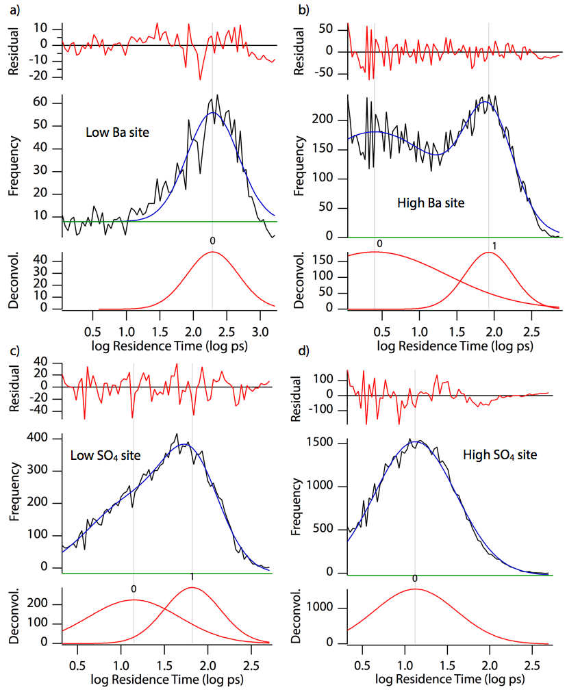

**Figure 6**. Distributions of the residence time of water exchange events observed on each of the four sites on the barite {001} surfaces at 300 K. For each set of three plots, a histogram of the frequency of observations as a function of the log of the residence time is shown in black, with a model fit containing one or two log-normal distributions shown in blue, along with the residuals for the fit shown in red above it and a deconvolution of the peaks shown in red below it. See Figure 2 for structure of the sites. a) Low barium site, only a single distribution of exchanges is observed with a mean residence time of 194 ps. b) High barium site, two distributions of exchanges are fit to the histogram with mean of 3 and 84 ps. c) Low sulfate site, two distributions of exchanges are fit at 12 and 65 ps. d) High sulfate site, only a single distribution of exchanges with mean residence time of 14 ps is observed.

**Table of Contents Image:**

